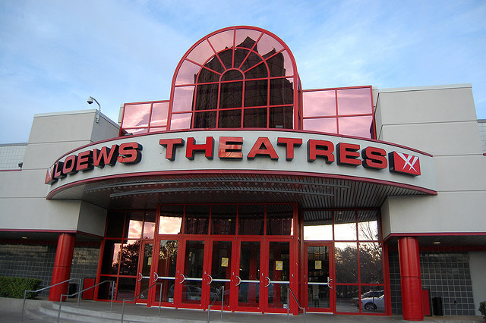
Loews Movie Theatre
2121 Route 38, Cherry Hill, NJ
Departure from XL: 9:30 AM
Arrival at trip: 10:00 AM
Departure from trip: 12:30 PM
Arrival at XL: 1:00 PM
We will not know the exact movie we are seeing middle of June at the earliest. We will post it here as soon as we get the information. We will make sure that it is age appropriate.
PLEASE REMEMBER:
- Camp shirt must be worn.
- Every camper will receive popcorn, fruit snack and a drink.
- Additional snacks can be purchased when we arrive at the theatre
- Campers must bring a lunch with them to the trip. They will eat when the movie is over prior to returning to camp.
- Water will be provided for them on the trip.
- Campers will not be permitted to use the arcade on this trip.

