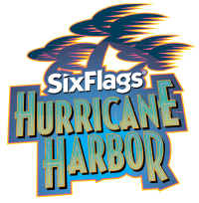
Six Flags Hurricane Harbor
1 Six Flags Blvd., Jackson, NJ

Leave XL: 9:30 AM
Arrive: 10:45 AM
Leave trip: 3:30PM
Arrive at XL: 5:00 PM

PLEASE REMEMBER:
- Camp shirt must be worn.
- Apply sunblock before coming to camp. Campers should bring sunscreen to reapply.
- All campers must wear their bathing suit under their camp shirt to camp.
- Campers can bring a change of clothes to change into when they return to XL.
- Campers are not permitted to change on any of the field trips.
- Campers should have a bag to keep all their belongings in while they are on the water rides.
- Bring a packed lunch (no glass).
- You may pack extra snacks in your backpack.
- Campers will eat lunch in the designated lunch area inside the park.
- After lunch, snacks purchases are permitted.
- No souvenirs may be purchased on this trip.
- Water will be available throughout the day.
- Campers will receive snacks prior to getting on the bus to return to
XL

