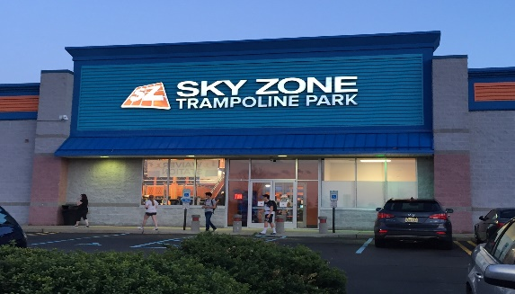
This Photo by Unknown Author is licensed under CC BY-NC-ND
Sky Zone Moorestown
2834 Rt. 73
Maple Shade, NJ

Departure from ISC: 9:30 AM
Arrival at trip: 10:15 AM
Departure from trip: 1:00 PM
Arrival at ISC: 1:45 PM
Parents – All campers must have an active waiver to participate in the trip. Sky Zone requires you to fill it out on their website. Campers will not be able to participate unless you have completed the waiver. . We will also have them available at check in the day of the trip.
PLEASE REMEMBER:
- Camp shirt must wear their camp shirt
- Wear comfortable clothes. Socks are included with our package.
- Bring a packed lunch (no glass). You should pack extra snacks.
- Campers will eat lunch at Sky Zone.
- After lunch campers can purchase snacks from the snack bar.
- Water will be available for the campers.

