Date : 7/8
Grades: 5,6,7,8
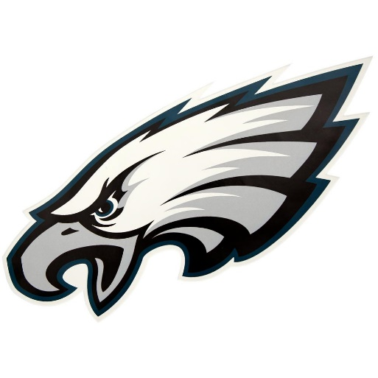

Lincoln Financial Field

Departure from XL: 9:30

Arrival at Trip: 10:30

Departure from trip: 1:30

Arrival at XL: 2:15 pm

Philadelphia Eagles Stadium Tour:
On the tour, you’ll visit the field, Eagles Locker Room, post-game Eagles Interview Room, the Press Box, the Broadcast Booth and a suite. Our stadium tours cover the Go Green program, including solar/wind energy production and recycling efforts. Our stadium tours cover the Go Green program, including solar/wind energy production and recycling efforts. We will get a chance to see the Super Bowl LII Lombardi Trophy!!!

Please Remember:

- Camp shirt must be worn.
- Bring packed lunch (no glass)
- Sneakers and socks are required
- No Backpacks, food or beverages allowed in stadium.
- We will leave our backpacks on the bus.
- After the tour we will eat lunch at the picnic tables outside the stadium before returning to camp.
- Water will be available throughout day

