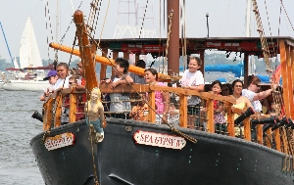
Pirate Adventure
http://www.jerseyshorepirates.com/

Departure from XL: 9:30AM
Arrival at trip: 10:30 AM
Departure from trip: 2:00 PM
Arrival at XL: 3:15 PM
Campers will embark on their own pirate adventure as crew members of the Sea Gypsy II. The experience includes face painting, dress up, and a 75-minute, action-packed voyage on the open seas. Campers will also have time to eat lunch and play in nearby Windward Beach Park. However, they will not be permitted in the water on this trip so they do not require swimsuits.
PLEASE REMEMBER:
- Camp shirt must be worn.
- Campers do not need to wear swimsuits on this trip.
- Bring a packed lunch (no glass).
- Campers will eat lunch in the designated lunch area.
- After lunch, snack purchases may be available, time permitting.
- No souvenirs or additional snack will be purchased on this trip.
- Water will be available throughout the day.
- When not on the ship campers will be able to play in nearby Windward Beach Park.
- Sunscreen should be applied prior to coming to camp.

