5th- 8th – 7/22

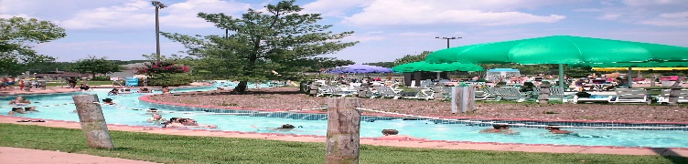
This Photo by Unknown Author is licensed under CC BY-SA
Thundering Water Park
750 N. Bay Avenue, Beach Haven, NJ 08008

Departure from XL: 9:30 AM
Arrival at trip: 10:45 AM
Departure from trip: 3:30 PM
Arrival at XL: 4:45 PM
We will arrive in LBI at 10:45. We will park the bus by the bay and playground. We will not be swimming in the bay. Campers will be able to wade in the very shallow area. We will have lunch at the picnic tables overlooking the bay. After lunch we will head down to the water park from 1 pm – 3 pm.
- They will stay with their grade while in the park.
- All campers must bring a lunch and snacks and a drink (no glass)
- Campers must have their bathing suit on under their clothes when they arrive at camp. Campers will not be permitted to change while on the trip. Campers should wear comfortable clothes over their bathing suit, and we recommend a hat.
- Sunscreen should be applied before coming to camp that day and all campers should bring sunscreen to reapply after lunch.
- Campers will have time to visit the snack stands after lunch.
- Campers are not permitted to change clothes unless there is an emergency on trips. They can bring dry clothes to change into when they return to XL.

